STATISTICAL ANALYSIS

PRISM III 24 score and predicted PICU mortality rate was estimated to evaluate the suitability of PRISM III in our population For the analysis of mortality risk factors, patients were allocated into two groups according to PRISM III 24 score values >8 and ≤ 8, based on the data given showing increased mortality risk in patients with PRISM III 24 score >8.

Table 1: The outcome of the entire population.

|  |  |
| --- | --- |
| Outcomes | Percentage |
| Number Patient of patient in the ward | 82.5 |
| Died | 17.5 |
| Total | 100 |

Table 2: PRISM score and mortality

|  |  |
| --- | --- |
| Score | Frequency |
| >8 | 193 |
| ≤8 | 13 |

|  |  |  |  |  |
| --- | --- | --- | --- | --- |
|  | | Mortality | | Total |
| Survived | Died |
| PRISM III 24 Score | >8 | 123(63.73%) | 70(36.53%) | 193(100%) |
| ≤8 | 12(92.31%) | 1(7.69%) | 13(100%) |
|  | Total | 135(65.53%) | 71(34.47%) | 206(100%) |

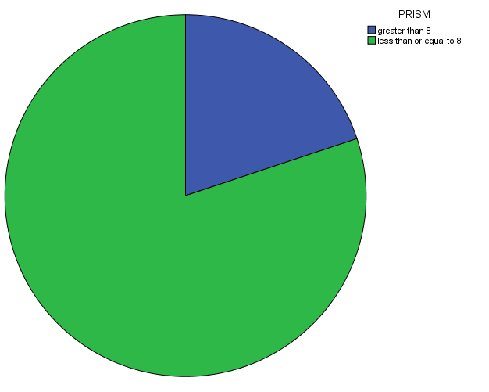

Figure-1: Pie chart showing PRISM score frequency

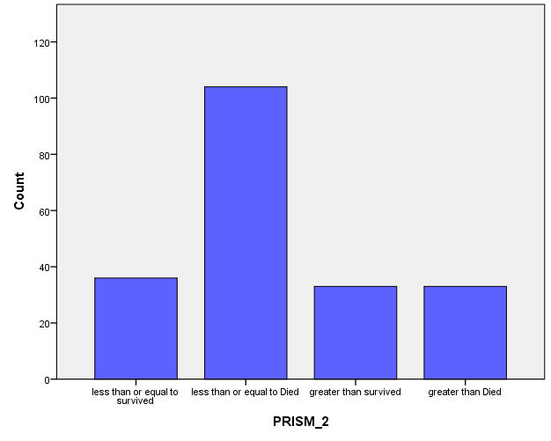

Figure-2: Shows the relation between PRISM score and mortality

Univariate analysis was performed through chi-square test and relative risk estimation with 95% confidence intervals. Cox proportional hazards were used for survival analysis. Statistical significance was set at a p-value of < 0.05.

RESULTS

We enrolled a total of 206 patients in our study of which 115 patients were males, and 91 patients were females. The outcome was assessed regarding death or discharge from the Pediatric Intensive Care Unit.

In the calculation of PRISM score of our study population, we allocated patients into two categories by PRISM score and found that 13 patients had a PRISM score >8 at

admission (table-1). We concluded that PRISM score was a significant predictor of mortality. Mean total PRISM III-24 score was 1.7670±0.02953. Patients with a PRISM score ≤8 at admission had a significantly higher mortality than those with a PRISM score >8 (figure-1, table-2). Chi-square value was 8.362 and p-value was <0. 001. The odds ratio of dying in the presence of PRISM score ≥8 was 9.28 with a 95% CI of 2.47 to 7.43.

Figure-2 shows the relation between PRISM score and Mortality

Cox regression analysis of PRISM III 24 score as a predictor of mortality showed that it is an independent predictor with a p-value of 0.868 and 95% CI between -0.306 and 0.363 making it statistically significant (figure-2, table-3).

CONCLUSION

To conclude PRISM III 24 score is a good indicator of the initial severity of illness because a higher PRISM score is associated with higher mortality. In a country with limited resources like India there are few tertiary care referral centers for pediatric admission. In such cases PRISM III 24 score can serve as a useful guide as to which patients need intensive care. In addition to this the PRISM score has a role in the prediction of illness severity initially. In clinical epidemiology, PRISM score can serve as a useful marker to include or exclude patients from a particular study in clinical trials.